https://doi.org/10.51301/ce.2024.i4.04

Modeling and Control of a Quadrotor Unmanned Aerial Vehicles
M. Zharkyn*
Satbayev University, Almaty, Kazakhstan
*Corresponding author: m.m.jarkyn@gmail.com
Abstract. The purpose of this study is to conduct a comprehensive analysis of the system modeling of quadcopter unmanned aerial vehicles and to develop effective algorithms for controlling both the position and the flight path. The main focus is on testing and approbation of the developed systems both in a virtual simulation environment and on a real platform. The Crazyflie quadrocopter with open source code was chosen as the object of research, which provides flexibility in configuring and adapting control algorithms. The initial stage of the study includes the development of a mathematical model that describes the dynamics of a quadcopter. Then, a modeling environment is created that allows you to design and test the control architecture, including the use of cascading position tracking algorithms of the PID type. The built-in software for controlling the Crazyflie quadcopter is an innovative system based on a two-stage PID control scheme. This scheme provides precise and stable control of pitch and roll angles during flight. This two-stage PID control scheme provides high stability and precision control of the quadcopter in various flight conditions, allowing it to remain stable and controlled even with sudden environmental changes or mission requirements. Thanks to this technology, Crazyflie can successfully perform a wide range of tasks and be used in various fields, from academic research to industrial applications and entertainment purposes. The results of this study will contribute to a deeper understanding and implementation of nanoquadrocopter management strategies.
Keywords: UAV, quadcopter, aircraft, control, PID controller, simulation.

1. Introduction
Quadrotor Unmanned Aerial Vehicles (QUAVs) have gained significant importance due to their clear advantages over conventional aircraft. Researchers are increasingly focused on enhancing QUAV performance for both military and civilian [1-3] applications, such as mapping, exploration, package delivery, and surveillance of indoor or outdoor environments. However, QUAVs face significant challenges, including under-actuation, strong coupling, multivariable dynamics, and unknown nonlinearities, particularly concerning vertical take-off and landing, autonomous hovering, and maneuvering. Consequently, controlling QUAVs appears to be a relatively complex and demanding task.
The landscape of quadcopter technology has undergone remarkable transformations in recent years, characterized by notable reductions in both cost and size. These advancements have democratized access to quadcopters, making them increasingly accessible and appealing to a diverse range of users, from researchers and professionals to hobbyists and enthusiasts. The convergence of technological innovations, such as miniaturization of components, advancements in battery technology, and improvements in control systems, has played a pivotal role in driving this evolution.
One of the key drivers behind the proliferation of quadcopters is the democratization of drone technology, which has lowered barriers to entry and fostered widespread adoption. As costs have decreased and performance has improved, quadcopters have transitioned from specialized research tools to mainstream consumer products. This democratization has led to a burgeoning ecosystem of applications spanning aerial photography, cinematography, precision agriculture, infrastructure inspection, and more.
Moreover, the accessibility of quadcopters has catalyzed innovation and experimentation among users, spurring a vibrant community of developers and enthusiasts. This community-driven ecosystem has contributed to rapid advancements in quadcopter technology, pushing the boundaries of what these versatile aerial platforms can achieve. As quadcopters continue to evolve and become more integrated into everyday life, the possibilities for their use and impact are poised to expand further, ushering in a new era of aerial exploration and innovation.
Beyond the economic benefits, manufacturers are now focused on enhancing autonomy, extending flight duration, boosting data processing capabilities, and ensuring adaptability to diverse environments, driving active research in quadcopters. A relatively recent development in this domain is the emergence of «nanoquads», characterized by their compact size and lightweight design, making them well-suited for indoor applications. The present project aims to investigate a commercial nanoquadcopter platform known as the «Crazyflie», developed by Bitcraze company. This nanoquad has swiftly garnered acclaim as one of the preferred platforms for quadcopter research [4,5].
The development and implementation of effective control algorithms are crucial for optimizing the performance and stability of quadcopter unmanned aerial vehicles (UAVs). In this context, a modeling environment is essential to facilitate the design, refinement, and testing of control architectures. One such approach involves leveraging cascading position tracking algorithms, particularly those of the Proportional-Integral-Derivative (PID) type. These algorithms play a pivotal role in regulating the quadcopter's position and flight path by continuously adjusting control inputs based on real-time feedback [6].
Specifically, the Crazyflie quadcopter features built-in software that incorporates an innovative two-stage PID control scheme. This scheme is designed to deliver precise and stable control over the pitch and roll angles during flight operations. The two-stage PID control architecture enhances stability and responsiveness, allowing the quadcopter to maintain control even in challenging flight conditions characterized by sudden environmental changes or mission-specific requirements.
The effectiveness of the two-stage PID control scheme lies in its ability to dynamically adjust control parameters based on the quadcopter's response to external stimuli. This adaptive approach ensures high stability and precision, thereby enabling the quadcopter to perform reliably across a wide range of operational scenarios. Through the utilization of advanced control algorithms like the two-stage PID scheme, quadcopter technology continues to evolve, enabling enhanced performance and expanded applications in research, industry, and recreational settings.
This paper presents a comprehensive mathematical model of the Crazyflie nanoquadcopter, establishing a critical foundation for developing an advanced simulation environment and designing sophisticated control algorithms. Substantial effort was dedicated to thoroughly understanding the operational dynamics of the system and precisely identifying key physical parameters. This meticulous approach ensures that the simulation accurately reflects the complex behavior of the Crazyflie, thereby enhancing its relevance and effectiveness for real-world applications. By leveraging this detailed mathematical model, researchers can confidently explore and validate control strategies, ultimately improving the performance and practical applicability of the Crazyflie in various operational scenarios.

2. Materials and methods
The work leverages the Bitcraze Crazyflie platform, which features four coreless DC rotors arranged in a cross formation. Each rotor is equipped with a lightweight plastic propeller and operates autonomously, with alternating rotations between the odd and even-numbered rotors. This configuration allows the quadcopter to achieve stable flight by adjusting the speeds and directions of the rotors based on control inputs. The use of coreless DC motors contributes to the quadcopter's compact size and agility, making it well-suited for indoor applications and maneuvering in confined spaces. Additionally, the independent operation of each rotor enhances the quadcopter's ability to execute complex flight maneuvers and respond quickly to control commands. The Crazyflie platform's design and capabilities serve as a versatile foundation for conducting research and experimentation in the field of unmanned aerial vehicles, particularly in the development and validation of control algorithms for precise and stable flight performance.
Vertical motion in the Crazyflie quadcopter is achieved by simultaneously adjusting the speed of all four rotors. By increasing or decreasing the collective thrust generated by the rotors, the quadcopter can ascend or descend while maintaining its orientation. Roll rotation, which causes the quadcopter to tilt sideways, is induced by varying the speed of the even-numbered rotors (e.g., motors 2 and 4) in opposite directions. Similarly, pitch rotation, altering the quadcopter's nose-up or nose-down attitude, results from changes in the speeds of the odd-numbered rotors (e.g., motors 1 and 3) in opposing directions. Moreover, yaw rotation, which rotates the quadcopter around its vertical axis, is generated by the opposing torques produced by each propeller pair. When the rotors on one side of the quadcopter spin faster than those on the other side, a torque imbalance occurs, causing the quadcopter to yaw left or right. This differential torque effect is essential for steering and orienting the quadcopter during flight maneuvers. Understanding these fundamental principles of quadcopter flight dynamics is crucial for designing effective control algorithms that govern the Crazyflie's behavior. By precisely adjusting rotor speeds based on control inputs, researchers can achieve stable and responsive flight performance, enabling the quadcopter to execute complex maneuvers with accuracy and agility. This knowledge serves as a cornerstone for developing advanced control strategies and optimizing the quadcopter's capabilities for various applications, from aerial photography and exploration to autonomous navigation and beyond.
The kinematics and dynamics models of the Crazyflie are developed using Newton-Euler equations, under the following assumptions [2]:
The propellers and body structure are rigid.
The Crazyflie structure is symmetrical.
The center of gravity coincides with the origin of the body frame.
The drag and thrust are determined by the square of the propeller speed.

3. Results and discussion
The motion of the Crazyflie is described using two coordinate frames. The body frame (B) is centered on the Crazyflie body and has axes (), while the earth inertial frame is fixed at ground level with axes (). The Crazyflie-UAV has six degrees of freedom (DOF): x, y, z, roll (φ), pitch (ϑ), and yaw (ψ). The first three represent height (z) and position (x, y), while the remaining three describe the orientation in space. Roll and pitch angles determine the Crazyflie's attitude, while yaw angle determines its heading. The absolute position of the Crazyflie is represented by the distance between the earth and body frames, denoted as d=[x y z]ᵀ. In Figure 1, the Crazyflie's orientation is depicted by roll, pitch, and yaw angles (φ, ϑ, ψ), indicating rotations around the body frame axes () respectively [5].
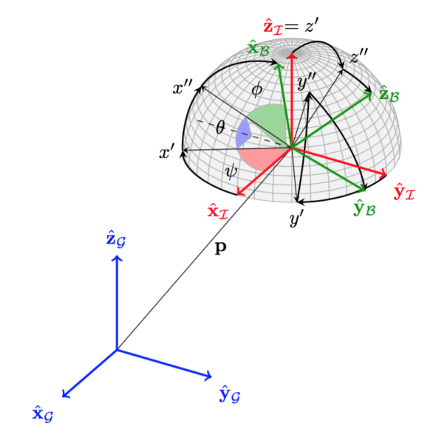
Figure 1. Body-fixed frame and Inertial frame
The position of the Crazyflie in the earth inertial frame is determined through a combination of sensor inputs and onboard processing. The quadcopter is equipped with sensors such as accelerometers and gyroscopes that measure linear acceleration and angular velocity, respectively. These sensor readings are processed by an onboard microcontroller or flight controller, which uses algorithms like sensor fusion (e.g., Kalman filters) to estimate the quadcopter's orientation and position relative to the earth's coordinate system.
To compute its position accurately, the Crazyflie utilizes a combination of inertial navigation techniques and external position sensing systems such as optical flow sensors or external motion capture systems. Inertial navigation relies on integrating acceleration measurements over time to estimate velocity and then integrating velocity to estimate position. However, inertial navigation alone is subject to drift over time due to sensor errors and biases. To mitigate drift and improve position accuracy, external sensors like optical flow cameras can be used to measure changes in position relative to the ground or motion capture systems that provide precise position measurements based on external markers.
The integration of sensor data and advanced algorithms allows the Crazyflie to maintain stable and precise positioning during flight, enabling it to perform tasks such as waypoint navigation, autonomous hovering, and trajectory following. This capability is essential for applications requiring precise control and positioning, such as aerial mapping, inspection, and surveillance. As quadcopter technology continues to evolve, improvements in sensor accuracy and algorithmic sophistication will further enhance the Crazyflie's capabilities and expand its range of practical applications. The position of the Crazyflie in the earth inertial frame is expressed as follows:
(1)
The transformation from the earth frame to the body frame in quadcopter dynamics involves converting coordinates and vectors between two different reference frames: the inertial earth frame and the body frame attached to the quadcopter. This transformation is crucial for interpreting sensor measurements, calculating control inputs, and understanding the quadcopter's orientation and motion relative to the earth. In the earth frame, coordinates are typically represented using a global coordinate system fixed relative to the earth's surface, such as latitude and longitude or Cartesian coordinates (x, y, z). In contrast, the body frame is attached to the quadcopter's center of mass and moves with the quadcopter during flight. The body frame typically has axes aligned with the quadcopter's principal axes of rotation: x (forward), y (right), and z (downward). To perform the transformation, rotation matrices or quaternion representations are used to rotate vectors from the earth frame to the body frame or vice versa. This rotation accounts for the quadcopter's orientation in space, which can change dynamically during flight maneuvers. The transformation involves applying rotations about the quadcopter's roll, pitch, and yaw axes to align the earth frame coordinates with the body frame coordinates.
Understanding and accurately implementing this transformation is essential for developing control algorithms that stabilize and maneuver the quadcopter based on sensor measurements. By transforming sensor data from the body frame to the earth frame, the quadcopter's position, velocity, and orientation can be accurately estimated and used for navigation and control purposes. This capability is critical for enabling autonomous flight, precision control, and navigation tasks in various applications, ranging from aerial photography and mapping to search and rescue missions. The transformation from the earth frame to the body frame, denoted as​ is defined as follows:
(2)
where c and s denote cosine and sine respectively.
The motion of the Crazyflie can be divided into two subsystems: the rotational subsystem (roll, pitch, and yaw) and the translational one (z, x, and y) [6]. Figure 2 illustrates the forces and moments exerted on the Crazyflie. Each rotor produces an upward thrust force and causes a moment ​ in a direction opposite to the rotation of the corresponding rotor n.

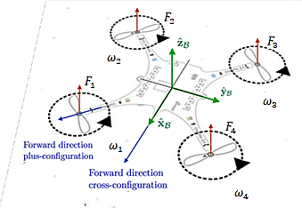
Figure 2. Acting Forces and Moments on Crazyflie
The total moments concerning the body frame are expressed as:
(3)
Where β and γ represent the constants of the aerodynamic force and moment, respectively, ϱ stands for the arm length of the Crazyflie, and ​ denotes the speed of each rotor. The gyroscopic moment ​, induced by the inertia of the rotors and the relative speed of the rotors ​, is defined as follows:
(4)
The equations governing rotational motion within the body frame are obtained through the application of the Newton-Euler method, presented in the following generalized format:
(5)
Where ω represents the angular body rates , and J is the diagonal inertia matrix of the Crazyflie, characterized by zero off-diagonal elements owing to the symmetrical Quadrotor's structure as stated in Assumption 2. It can be expressed as follows:
(6)
Where ​, and represent the moments of inertia about the x, y, and z axes of the body frame, respectively.
The equations governing the translational motion of the Crazyflie are derived within the earth's inertial frame utilizing Newton's second law, presented as follows:
(7)
Where m represents the mass of the Crazyflie and g denotes the acceleration due to gravity. In a horizontal orientation, the sole non-gravitational force F_{b}​ exerted on the Crazyflie is the thrust generated by the rotation of the propellers, expressed as follows:
(8)
To control the quadcopter, the initial step involved a comprehensive examination of the pre-existing controllers integrated into the stock firmware of the Crazyflie 2.0 (Firmware release 2016.02). This entailed studying the underlying control algorithms and parameters configured within the firmware to govern the quadcopter's flight behavior. By dissecting these embedded controllers, researchers gained insights into the default operational characteristics and limitations of the Crazyflie 2.0, laying the groundwork for subsequent controller design and optimization.
Following the analysis of the stock firmware controllers, the focus shifted towards evaluating their performance under varying flight conditions and maneuvers. This involved conducting systematic flight tests to assess how well the quadcopter responded to different control inputs and flight commands dictated by the embedded controllers. Observations from these experiments provided valuable feedback on the strengths and weaknesses of the default control strategies, identifying areas for potential improvement and optimization.
Armed with a deep understanding of the existing control framework, researchers proceeded to develop and implement novel control algorithms tailored to enhance the Crazyflie 2.0's maneuverability, stability, and overall performance. Leveraging insights gleaned from studying the stock firmware controllers, new control strategies were devised and tested to address specific challenges such as precise trajectory tracking, agile maneuvering, and robust stability in varying environmental conditions. This iterative process of controller refinement and enhancement aimed to unlock the full potential of the Crazyflie 2.0, enabling it to excel in a wide range of applications requiring agile and reliable unmanned aerial vehicle operations. Figure 3 illustrates the manufacturer-specified control architecture.

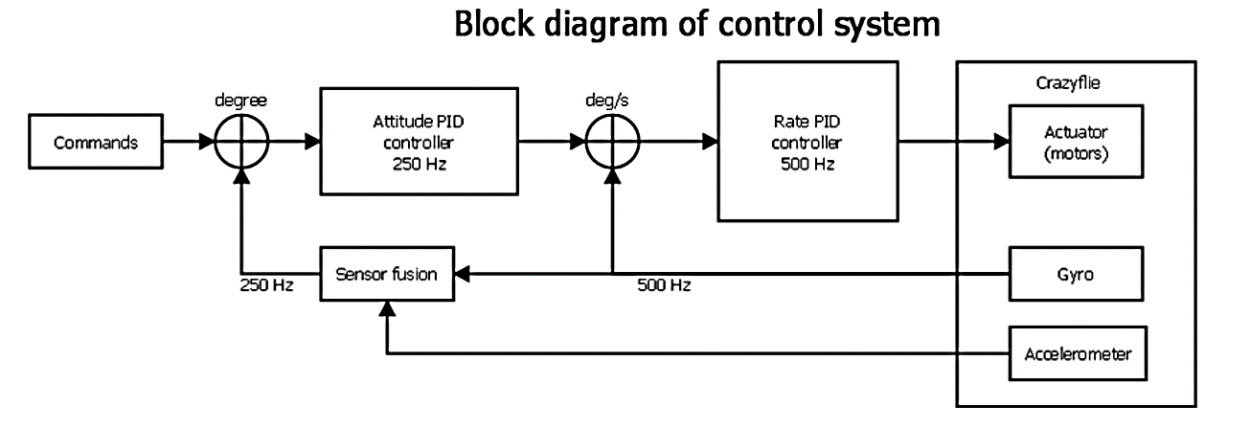
Figure 3. On-board control architecture, image courtesy of Bitcraze
The Crazyflie’s firmware incorporates a two cascaded PID control scheme to manage the pitch and roll angles. In a cascaded control structure, the architecture is decomposed into inner and outer control loops. Here, the outer loop regulates the inner loop, which subsequently governs the system's plant. A fundamental principle in cascaded structures dictates that the inner loop must operate at a faster rate than the outer loop. Ideally, the inner loop should stabilize at a steady-state value before the outer loop modifies the setpoint transmitted to it. Synchronization issues arise if the inner loop's response is inadequate or if the outer loop operates too swiftly. In practice, this disparity can be rectified by ensuring that the inner loop operates twice as quickly as the outer loop [4].

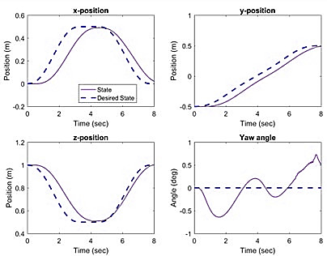
Figure 4. Trajectory simulation with cascade PID controller
The simulation results illustrated in Figure 4 reveal notable deviations from the desired trajectory, highlighting a significant discrepancy between the simulated and expected path. This outcome is largely attributed to the limitations of the controller, which was optimized solely for the nominal state of the system. To enhance trajectory tracking accuracy, there is a critical need to design and implement more sophisticated and adaptable controllers capable of dynamically responding to diverse environmental conditions and system perturbations. Developing such adaptive and robust controllers is imperative for ensuring precise trajectory following under varying operational circumstances. By integrating comprehensive system-awareness and accounting for multifaceted influencing factors, these controllers can effectively mitigate deviations and optimize performance across a spectrum of real-world conditions. This approach will ultimately foster improved trajectory tracking capabilities, enhancing the overall effectiveness and reliability of the system in achieving specified objectives.
This may involve the utilization of sophisticated adaptive control techniques or advanced feedback algorithms designed to swiftly adapt to dynamic changes within the system, enabling precise and prompt adjustments to control signals. Implementing these enhancements can lead to substantial improvements in system accuracy and efficiency across diverse operating conditions, thereby enhancing the reliability and predictability of task performance. These advancements are crucial for optimizing system management, ensuring robust performance even in challenging or unpredictable environments, and fostering enhanced overall operational effectiveness and reliability.

4. Conclusions
The study was undertaken with the primary objective of investigating the intricate dynamics of the Crazyflie 2.0, an open source nanoquadcopter, while concurrently developing an advanced simulation environment tailored for precise control design and subsequent validation in real-world scenarios. Nanoquadcopters like the Crazyflie 2.0 are rapidly emerging as the preferred platform for testing an array of control algorithms with varying complexities and applications. Consequently, there is a critical need to conceive a robust mathematical model of the vehicle capable of accurately predicting its dynamic behavior and evolution over time. To initiate this endeavor, the project commenced by meticulously modeling the nanoquadcopter, integrating insights gleaned from prior research, and identifying key physical parameters essential for simulation accuracy and control strategy development. This foundational work is paramount for advancing the state-of-the-art in unmanned aerial vehicle control, facilitating more nuanced and effective control algorithm testing and implementation. Through this comprehensive exploration and modeling effort, the study aims to contribute significantly to the evolving landscape of autonomous aerial robotics and control systems. In conclusion, the utilization of a modeling environment combined with innovative control algorithms, such as the two-stage PID scheme, has demonstrated significant advancements in enhancing the performance and stability of quadcopter unmanned aerial vehicles like the Crazyflie. By integrating cascading position tracking algorithms within a PID control framework, precise control over pitch and roll angles during flight operations is achieved, ensuring stability and responsiveness across diverse flight conditions.
The two-stage PID control scheme implemented in the Crazyflie's built-in software represents a notable innovation in quadcopter control systems. This scheme's adaptability and robustness enable the quadcopter to maintain stability and precise control even when faced with sudden environmental changes or mission-specific demands. The high level of stability and precision offered by the two-stage PID control enhances the quadcopter's capability to execute complex maneuvers and tasks reliably.
Moving forward, continued research and development in modeling environments and control algorithms will further refine quadcopter capabilities, enabling broader applications in fields ranging from research and industry to entertainment and beyond. The insights gained from this study contribute to the ongoing advancement of nanoquadcopter technology, paving the way for more sophisticated and versatile unmanned aerial vehicles capable of addressing evolving challenges and requirements in diverse operational environments.

References
- Forster, J. (2015). System Identification of the Crazyflie 2.0 Nano Quadrocopter. Thesis
- Greiff, M. (2017). Modelling and Control of the Crazyflie Quadrotor for Aggressive and Autonomous Flight by Optical Flow Driven State Estimation. M.S. thesis, Dept. of Automatic Control, Lund University, Sweden
- Hou, Z., Wang, W., Zhang, G. & Han, C. (2017). A survey on the formation control of multiple quadrotors. 14th International Conference on Ubiquitous Robots and Ambient Intelligence, URAI. https://doi.org/10.1109/URAI.2017.7992717
- Luis, C. & Ny, J.L. (2016). Design of a Trajectory Tracking Controller for a Nanoquadcopter. École polytechnique de montréal. ArXiv, abs/1608.05786
- Zekry, O.H., Attia, T., Hafez, A.T. & Ashry, M.M. (2023a). Modeling and Analysis of Non-linear Sliding Mode Control for UAV Path Following. IEEE Aerospace Conference Proceedings. https://doi.org/10.1109/AERO55745.2023.10115872
- Zekry, O.H., Attia, T., Hafez, A.T. & Ashry, M.M. (2023b). PID Trajectory Tracking Control of Crazyflie Nanoquadcopter Based on Genetic Algorithm. IEEE Aerospace Conference Proceedings. https://doi.org/10.1109/AERO55745.2023.10115538

Квадроторлы ұшқышсыз ұшу аппараттарын модельдеу және басқару
М. Жаркын*
Satbayev University, Алматы, Қазақстан
*Корреспонденция үшін автор: m.m.jarkyn@gmail.com
Аңдатпа. Бұл зерттеудің мақсаты-квадрокоптерлік ұшқышсыз ұшу аппараттарын жүйелік модельдеуге кешенді талдау жүргізу және ұшу жағдайын да, траекториясын да басқарудың тиімді алгоритмдерін әзірлеу. Негізгі назар виртуалды модельдеу ортасында да, нақты платформада да дамыған жүйелерді тексеруге және сынауға аударылады. Зерттеу нысаны ретінде crazyflie ашық бастапқы квадрокоптер таңдалды, бұл басқару алгоритмдерін теңшеу және бейімдеу икемділігін қамтамасыз етеді. Зерттеудің бастапқы кезеңі квадрокоптердің динамикасын сипаттайтын математикалық модельді әзірлеуді қамтиды. Содан кейін Басқару архитектурасын жобалауға және сынауға мүмкіндік беретін модельдеу ортасы жасалады, оның ішінде PID типті позицияны бақылаудың каскадты алгоритмдері қолданылады. Crazyflie квадрокоптерін басқаруға арналған кіріктірілген бағдарламалық жасақтама (бағдарламалық жасақтама)-бұл екі сатылы PID басқару схемасына негізделген инновациялық жүйе. Бұл схема ұшу кезінде қадам мен орам бұрыштарын дәл және тұрақты басқаруды қамтамасыз етеді. Бұл екі сатылы PID бақылау схемасы квадрокоптерді әртүрлі ұшу жағдайларында басқарудың жоғары тұрақтылығы мен дәлдігін қамтамасыз етеді, бұл оның қоршаған ортаның кенеттен өзгеруі немесе миссия талаптары кезінде де тұрақты және бақыланатын болуына мүмкіндік береді. Осы технологияның арқасында Crazyflie көптеген тапсырмаларды сәтті орындай алады және академиялық зерттеулерден бастап өнеркәсіптік қосымшалар мен ойын-сауық мақсаттарына дейін әртүрлі салаларда қолданыла алады. Осы зерттеудің нәтижелері наноквадрокоптерлерді басқару стратегияларын тереңірек түсінуге және іске асыруға ықпал етеді.
Негізгі сөздер: ұшқышсыз ұшу аппараттары, квадрокоптер, ұшу аппараттары, басқару элементтері, PID реттегіші, модельдеу.

Моделирование и управление квадрокоптерными беспилотными летательными аппаратами
М. Жаркын*
Satbayev University, Алматы, Казахстан
*Автор для корреспонденции: m.m.jarkyn@gmail.com
Аннотация. Цель данного исследования заключается в проведении комплексного анализа системного моделирования квадрокоптерных беспилотных летательных аппаратов и разработке эффективных алгоритмов управления как положением, так и траекторией полета. Основной упор делается на проверку и апробацию разработанных систем как в виртуальной среде имитационного моделирования, так и на реальной платформе. В качестве объекта исследования выбран квадрокоптер Crazyflie с открытым исходным кодом, что обеспечивает гибкость в настройке и адаптации алгоритмов управления. Первоначальный этап исследования включает в себя разработку математической модели, которая описывает динамику квадрокоптера. Затем осуществляется создание среды моделирования, которая позволяет проектировать и тестировать архитектуру управления, включая применение каскадных алгоритмов отслеживания положения типа PID. Встроенное программное обеспечение (ПО) для управления квадрокоптером Crazyflie представляет собой инновационную систему, основанную на двухкаскадной схеме ПИД-контроля. Эта схема обеспечивает точное и стабильное управление углами тангажа и крена во время полета. Эта двухкаскадная схема ПИД-контроля обеспечивает высокую стабильность и точность управления квадрокоптером в различных условиях полета, позволяя ему оставаться устойчивым и контролируемым даже при внезапных изменениях окружающей среды или требованиях миссии. Благодаря этой технологии Crazyflie может успешно выполнять широкий спектр задач и использоваться в различных областях, от академических исследований до промышленных применений и развлекательных целей. Результаты данного исследования будут способствовать более глубокому пониманию и реализации стратегий управления наноквадрокоптерами.
Ключевые слова: БПЛА, квадрокоптер, летательный аппарат, управление, ПИД-регулятор, моделирование.

Received: 14 August 2024
Accepted: 16 December 2024
Available online: 31 December 2024

